

Naresh R (13CS30024) Barnopriyo Barua (13CS30009)  
Software Engineering Assignment

MEDICAL LAB AUTOMATION SYSTEM

TEST SUITE RESULTS

Table of Contents

Integration Testing Results (Black Box Testing) 3

Login Page 3

Login Error for Management 3

Login error for unregistered user 3

Invalid Patient Name during Registration 4

Management Page 5

Test to be added already exists 5

No input while editing Tests 5

Test Charges containing non-digits are given as input 6

Adding an already existing Stock 6

Generation of Test Report 7

No Notifications Check 8

Patient Page 8

Test Report Collection earlier than specified Date 8

Unit Testing (White Box Testing) 9

Management_Page 9

Adding a Test 9

Removing a Test 11

Edit Test 13

Adding a Stock Item 14

Add Patient 16

Generation Of Bill 17

Generate Test Report 20

Low Stock Notification 22

Patient Page 23

Take Test 23

Collect Bill 24

Collect Test Report 26

# Integration Testing Results (Black Box Testing)

## Login Page

### Login Error for Management

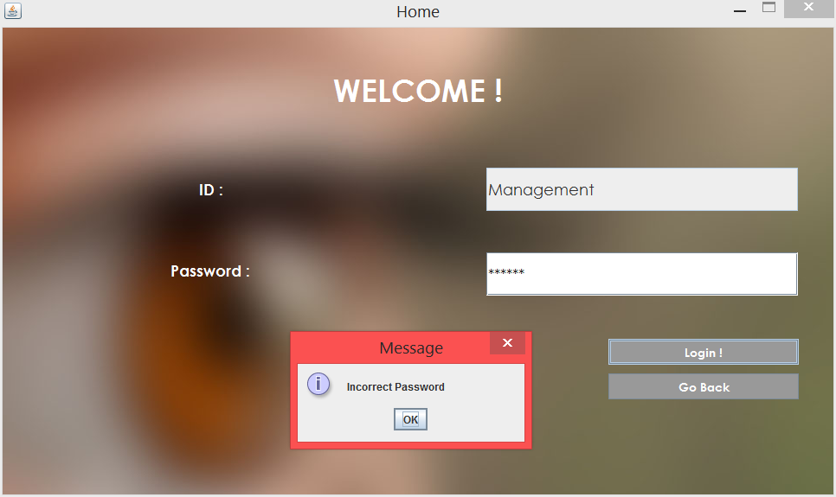

### Login error for unregistered user

#### Database before login attempt

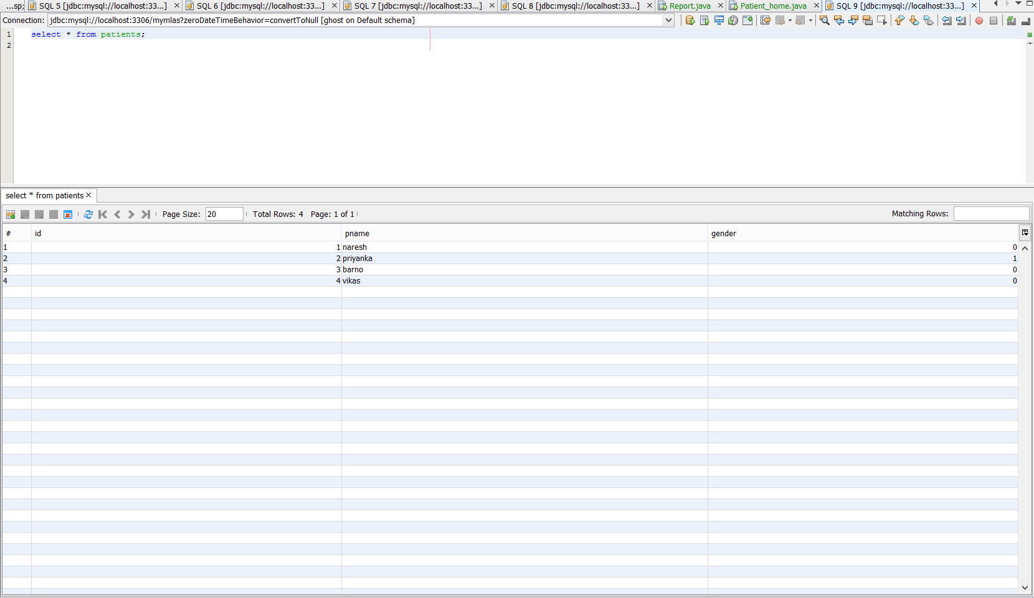

#### Error Displayed

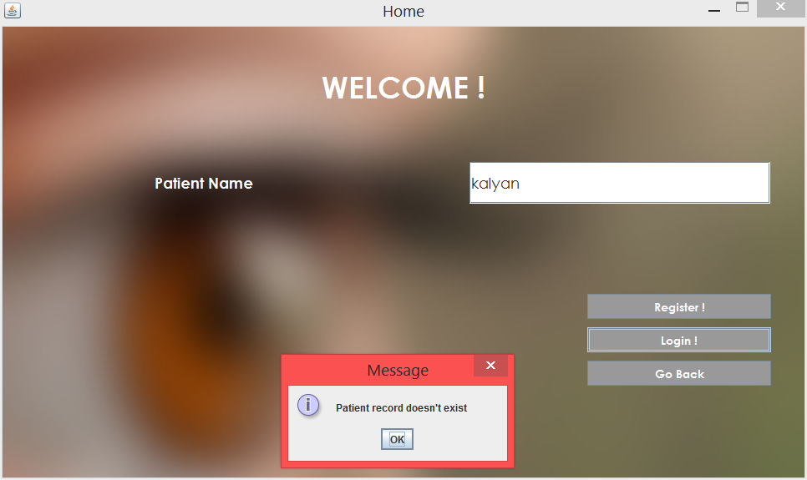

### Invalid Patient Name during Registration

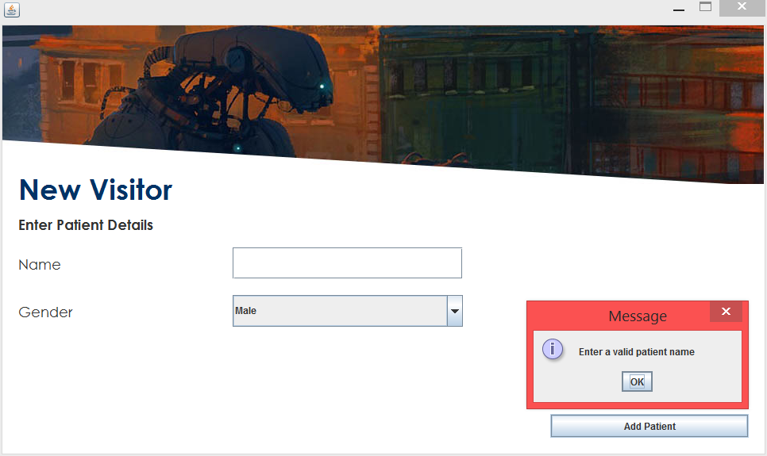

## Management Page

### Test to be added already exists

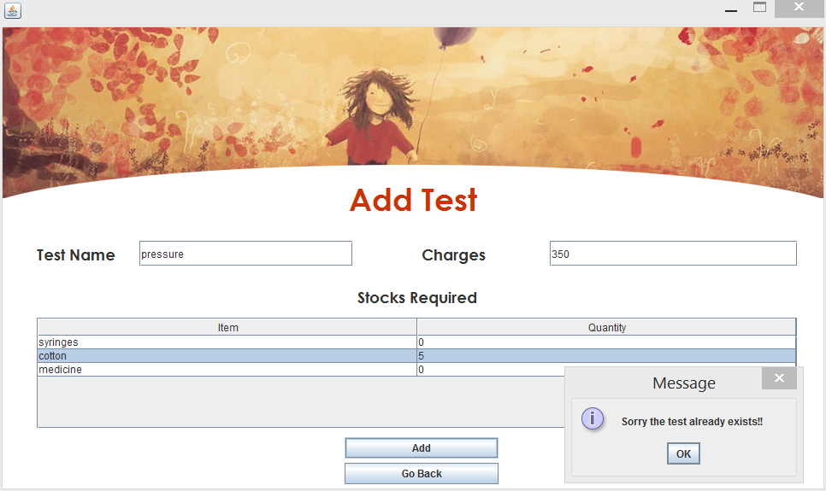

### No input while editing Tests

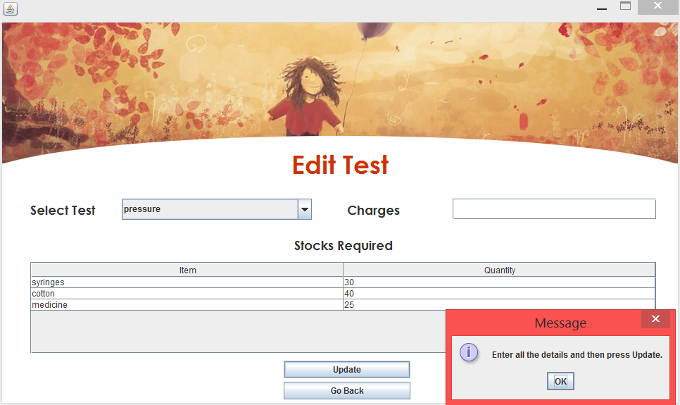

### Test Charges containing non-digits are given as input

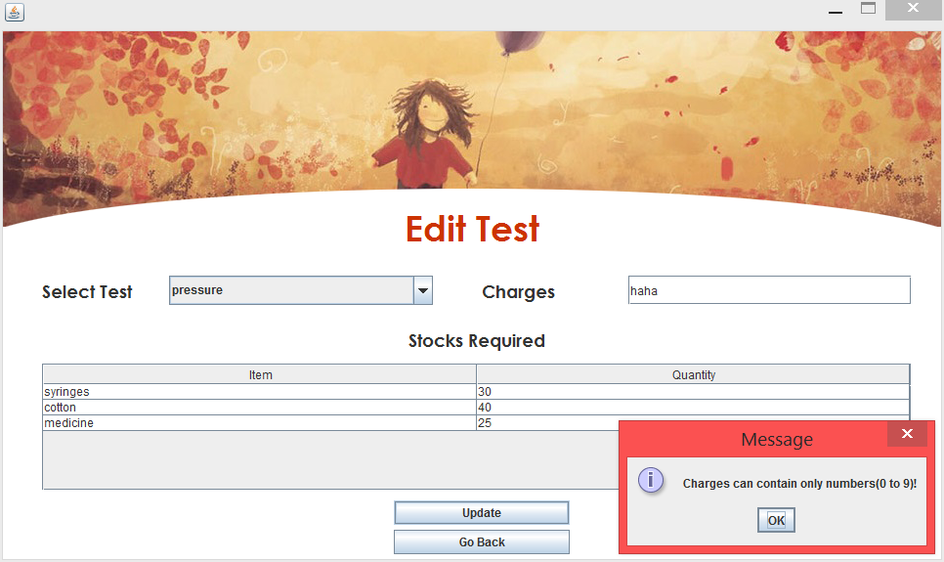

### Adding an already existing Stock

#### Stocks Table before Adding

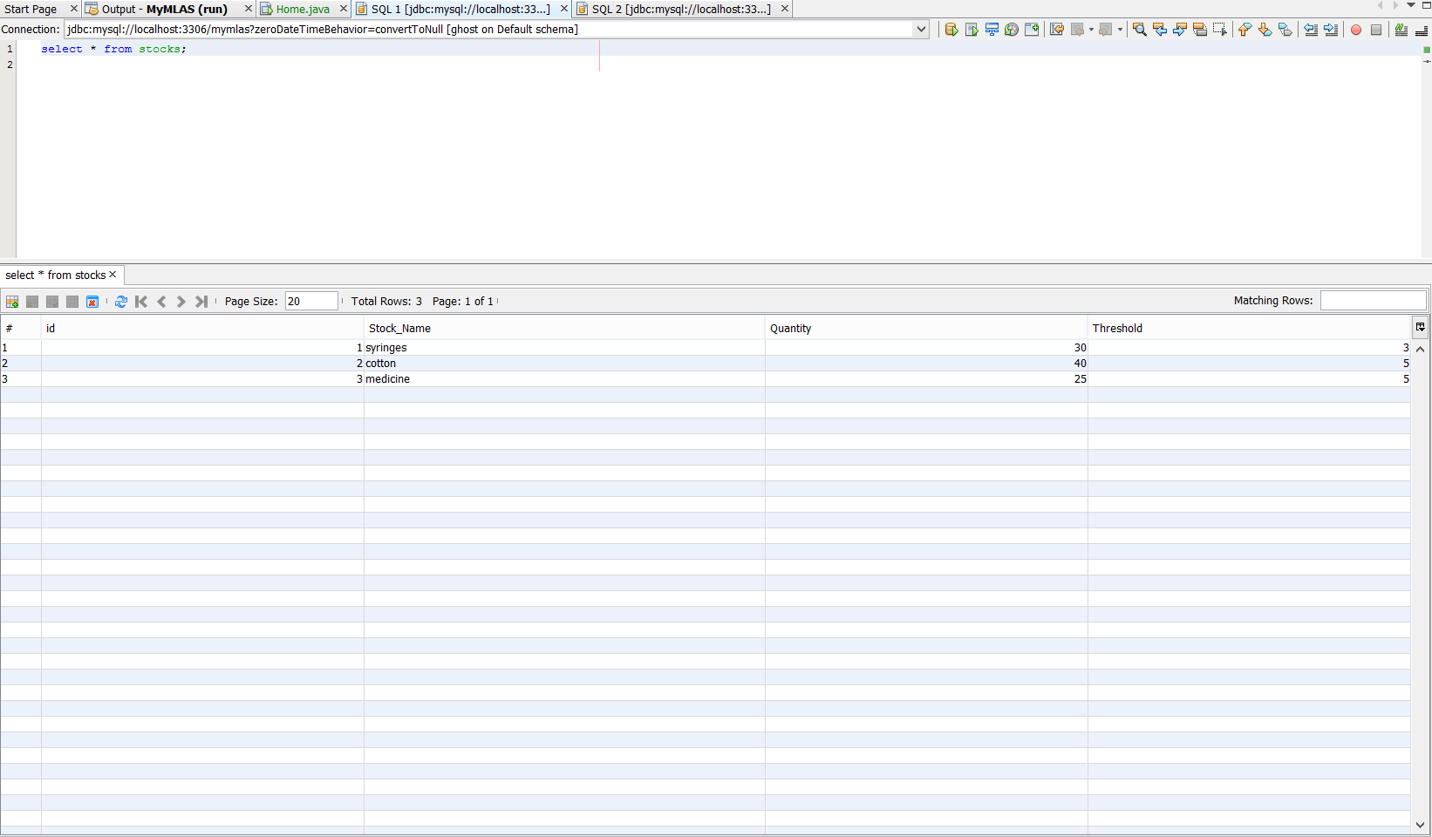

#### Error Message Displayed

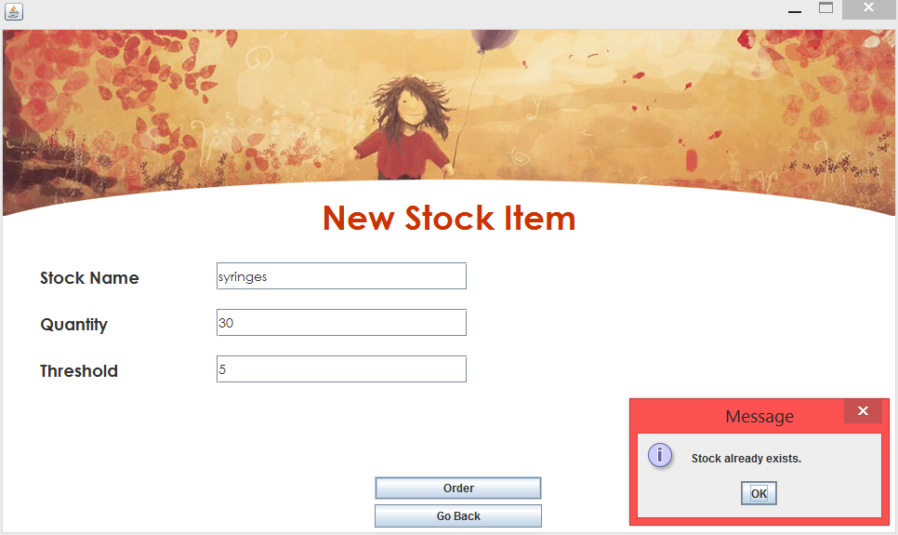

### Generation of Test Report

#### Patient Results not added

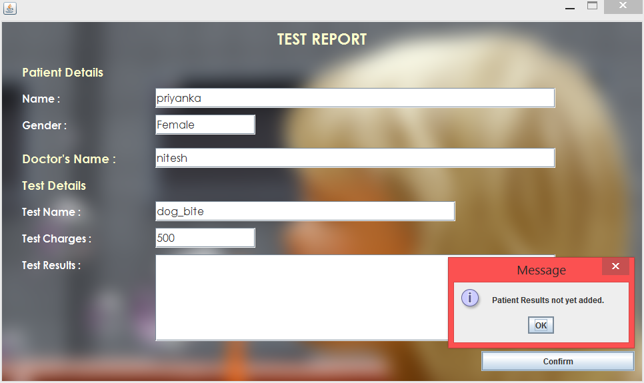

### No Notifications Check

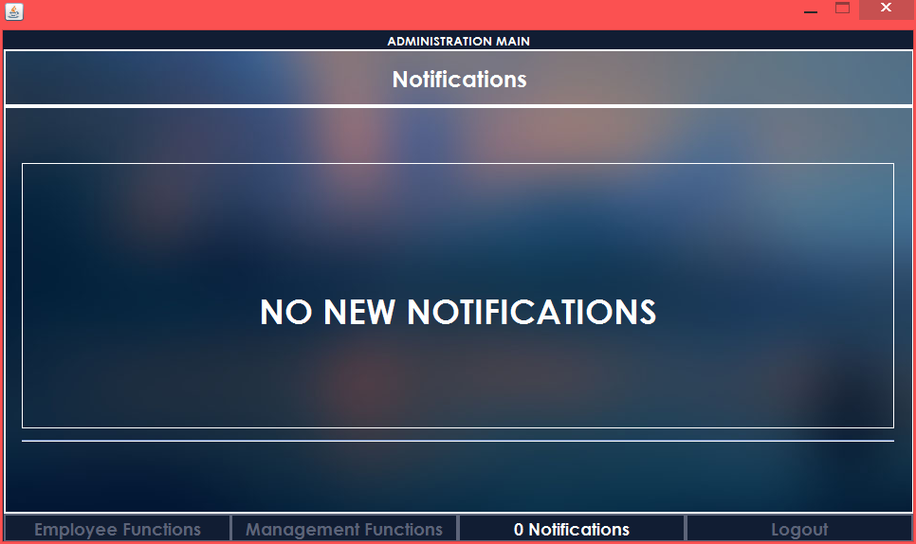

## Patient Page

### Test Report Collection earlier than specified Date

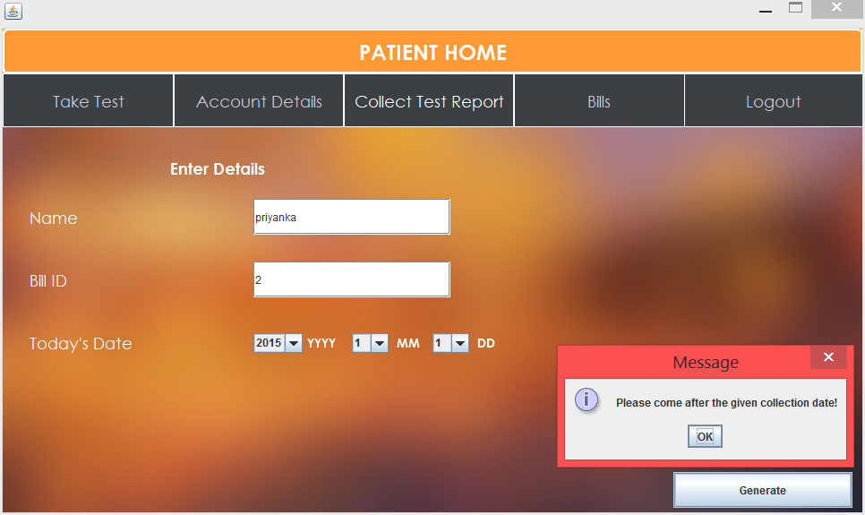

# Unit Testing (White Box Testing)

## Management_Page

### Adding a Test

#### Database before Adding the test

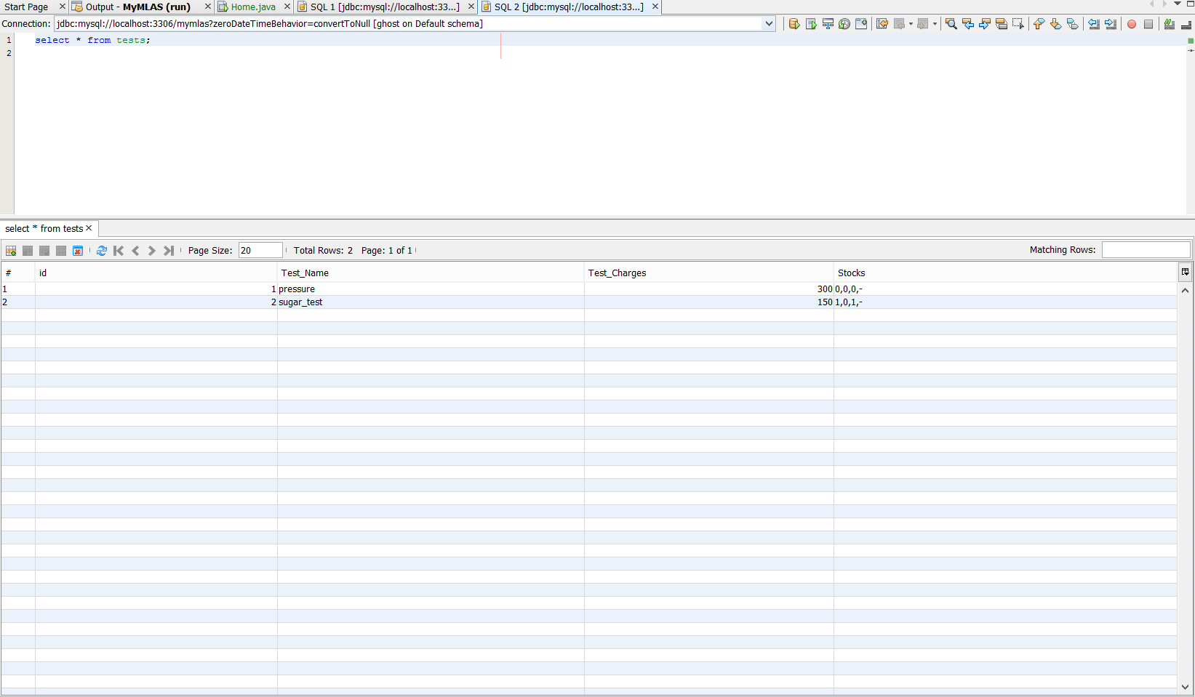

#### Success Result

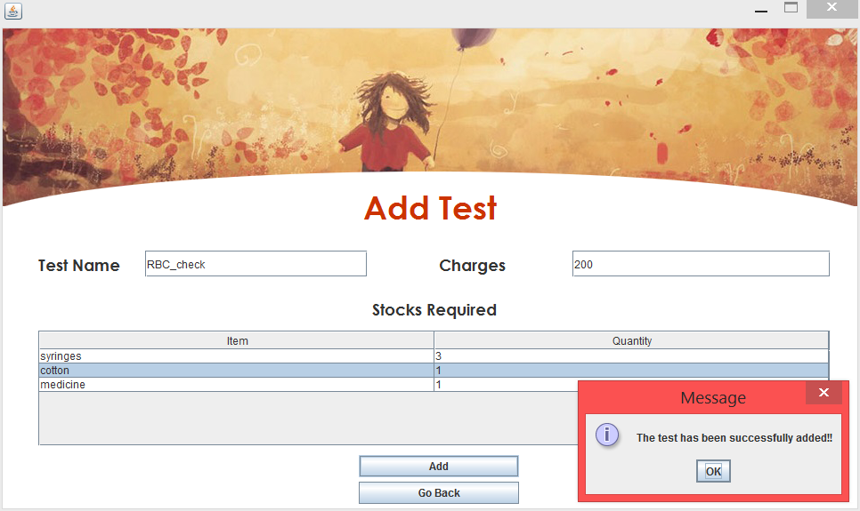

#### Database After adding Test

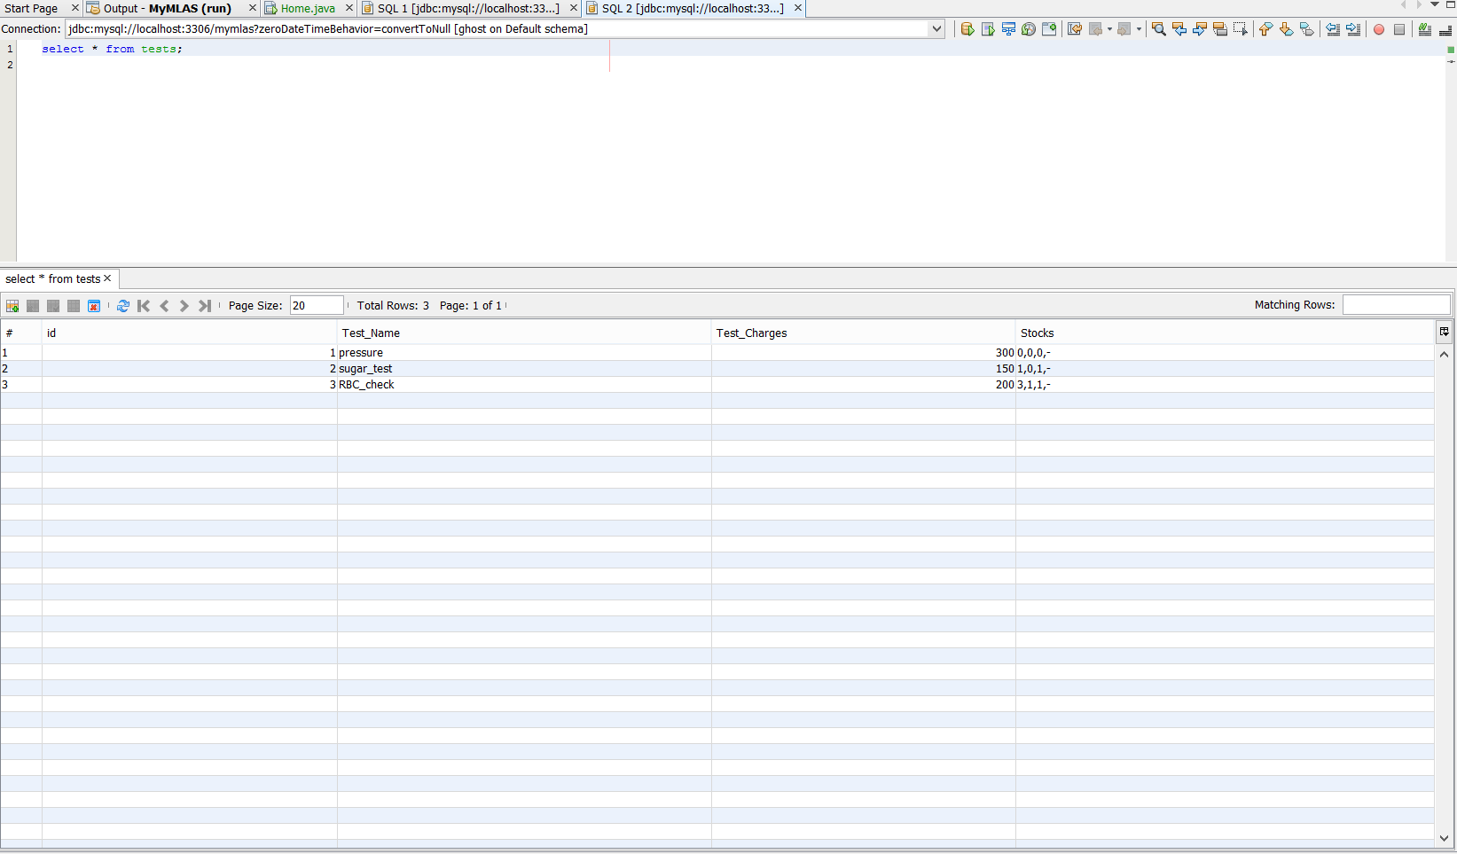

#### Tests listed after Adding

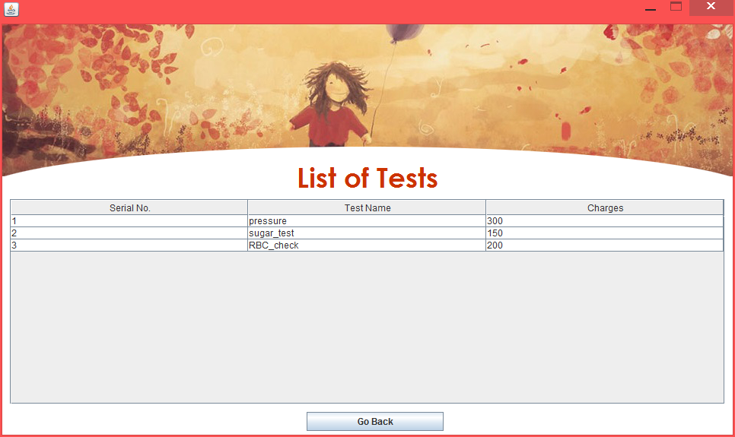

### Removing a Test

#### Database of Tests before removing

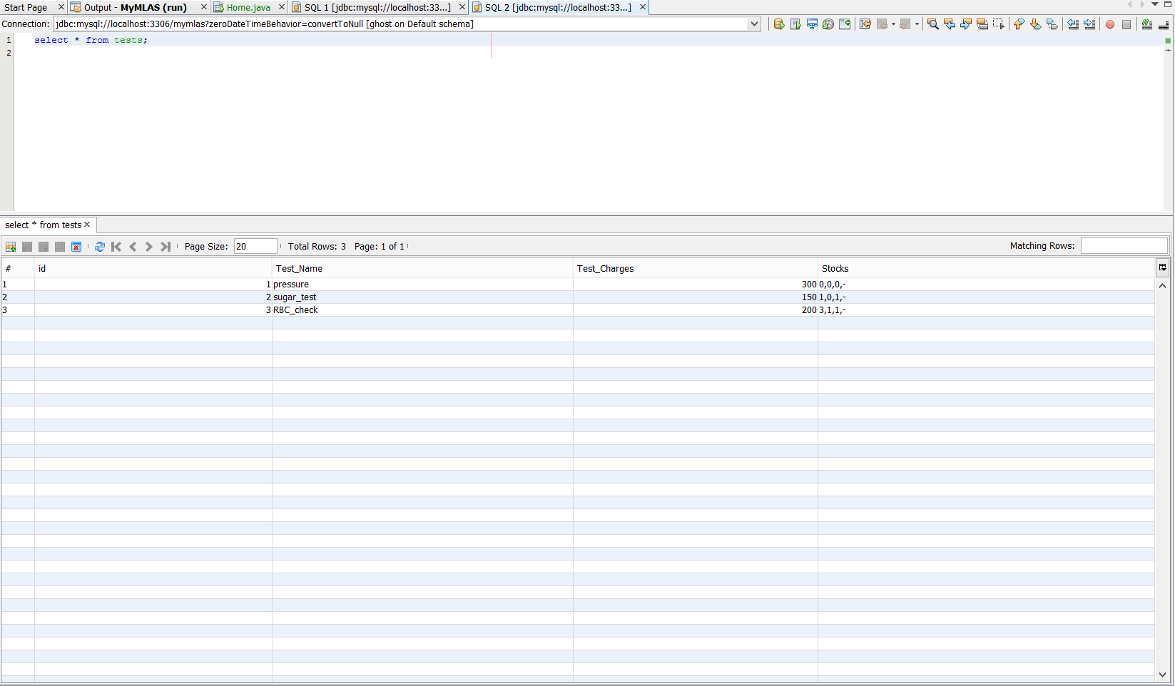

#### Remove Test (Success)

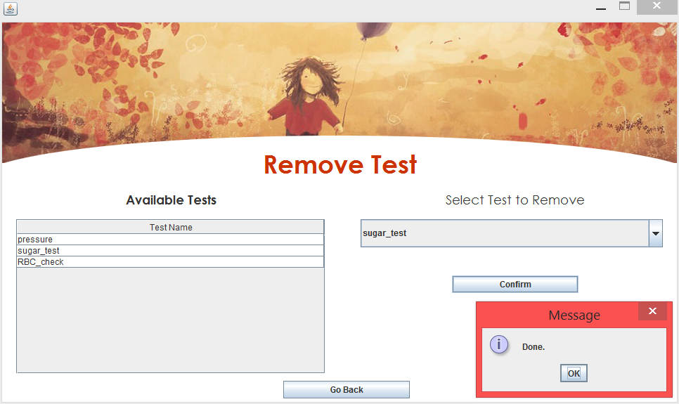

#### Database after removing a test

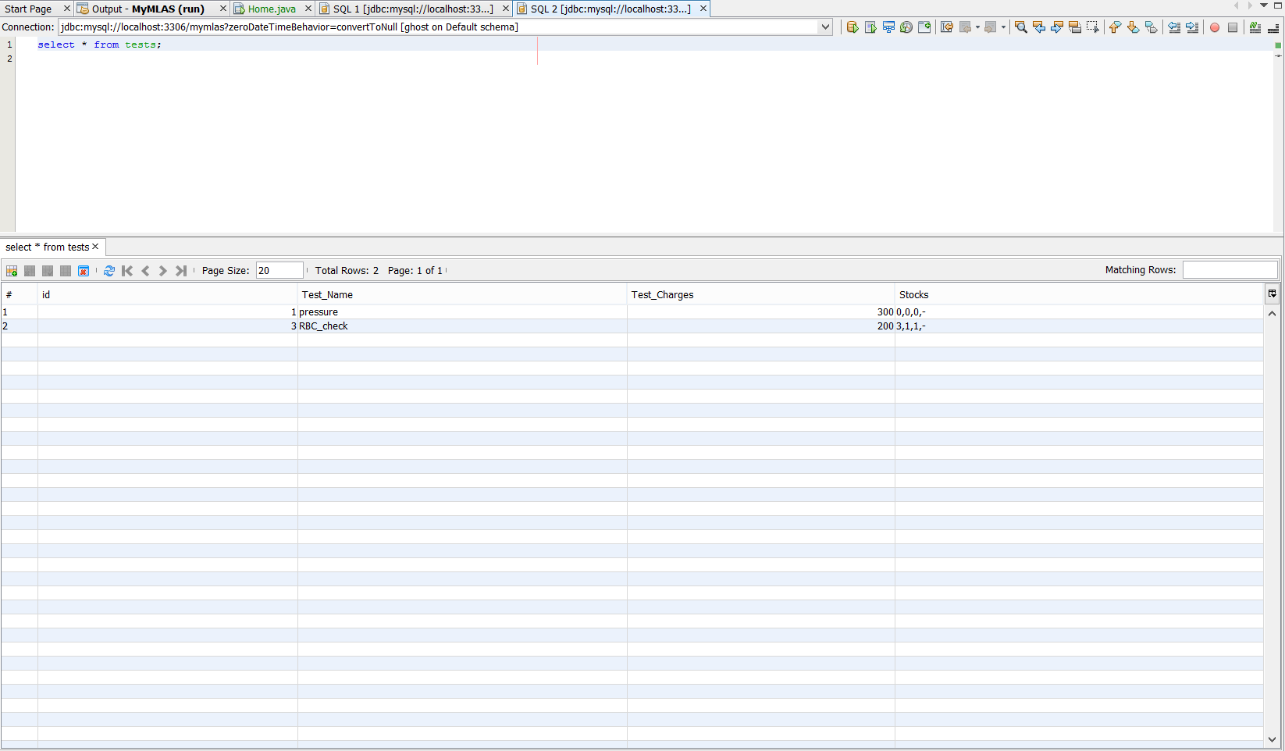

### Edit Test

#### Database before Editing Test

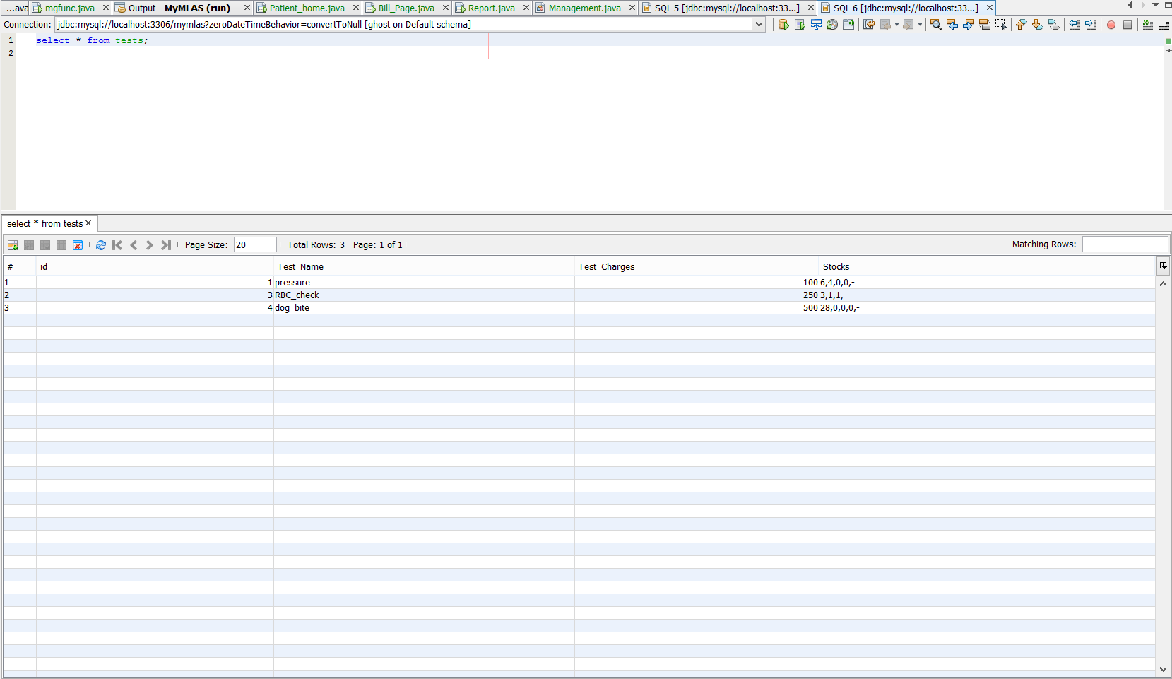

#### Edit Test (Success)

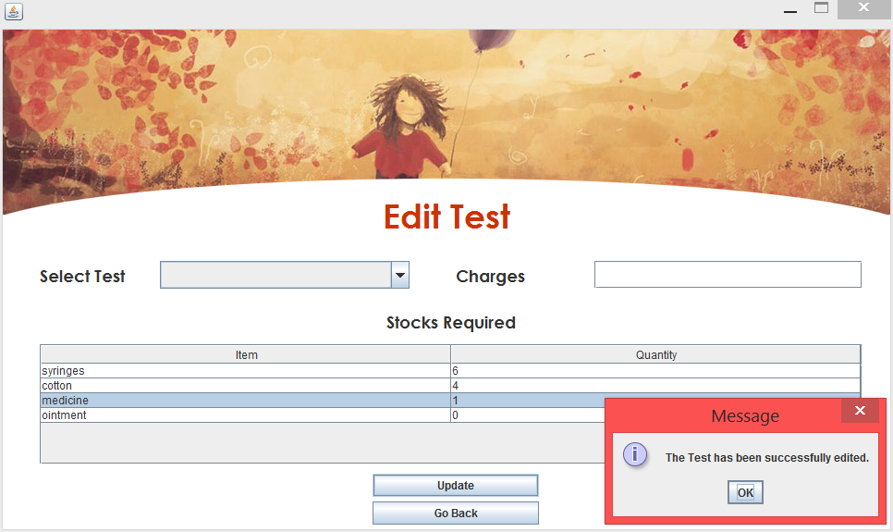

#### Database after Editing of Test

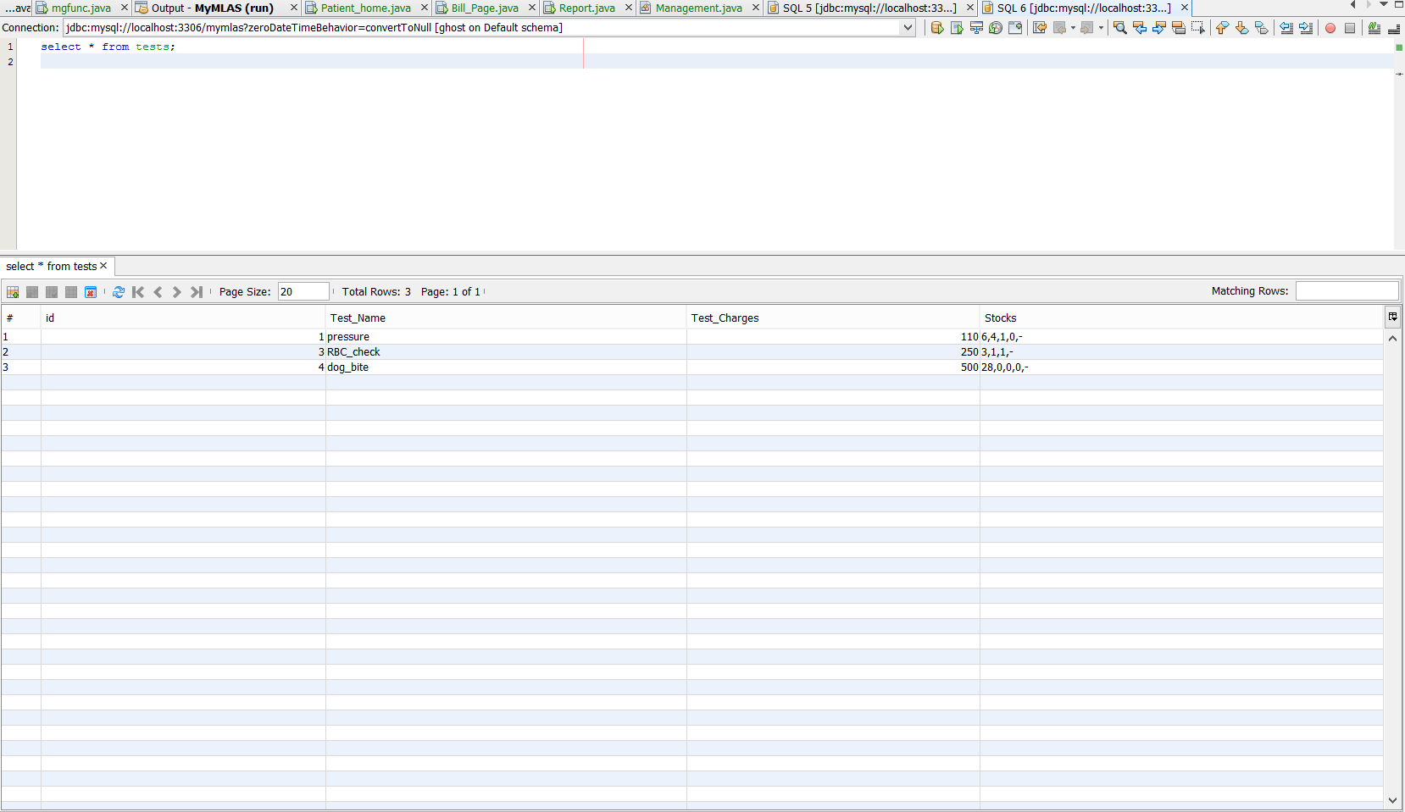

### Adding a Stock Item

#### Database (Stocks) before Adding



#### Add Stock (Success)

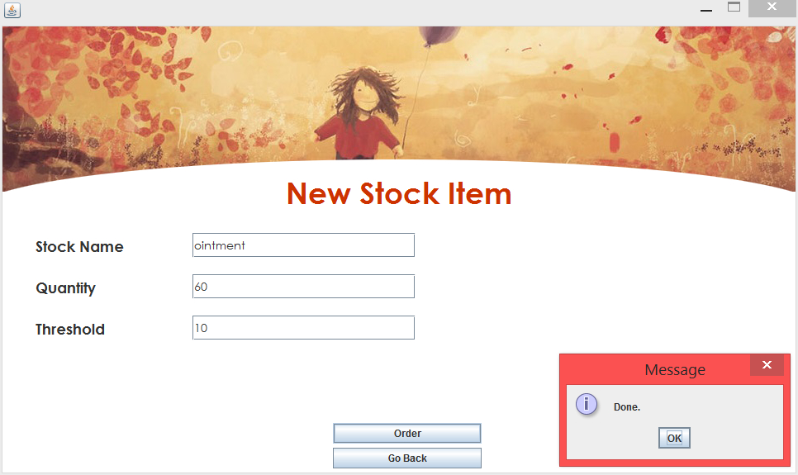

#### Database after Stock Added

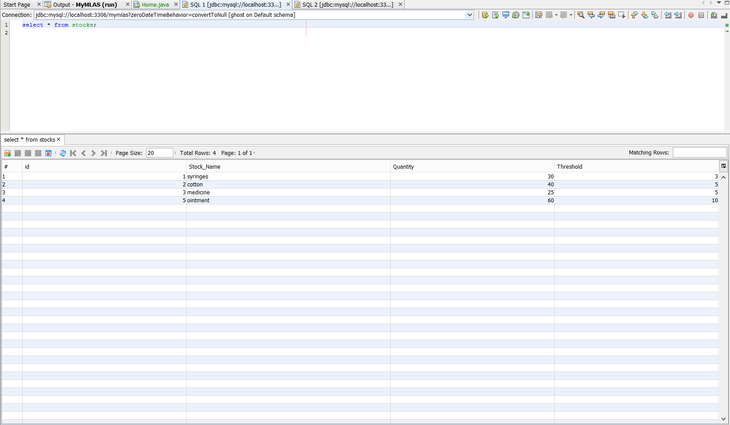

### Add Patient

#### Database before addition of Patient

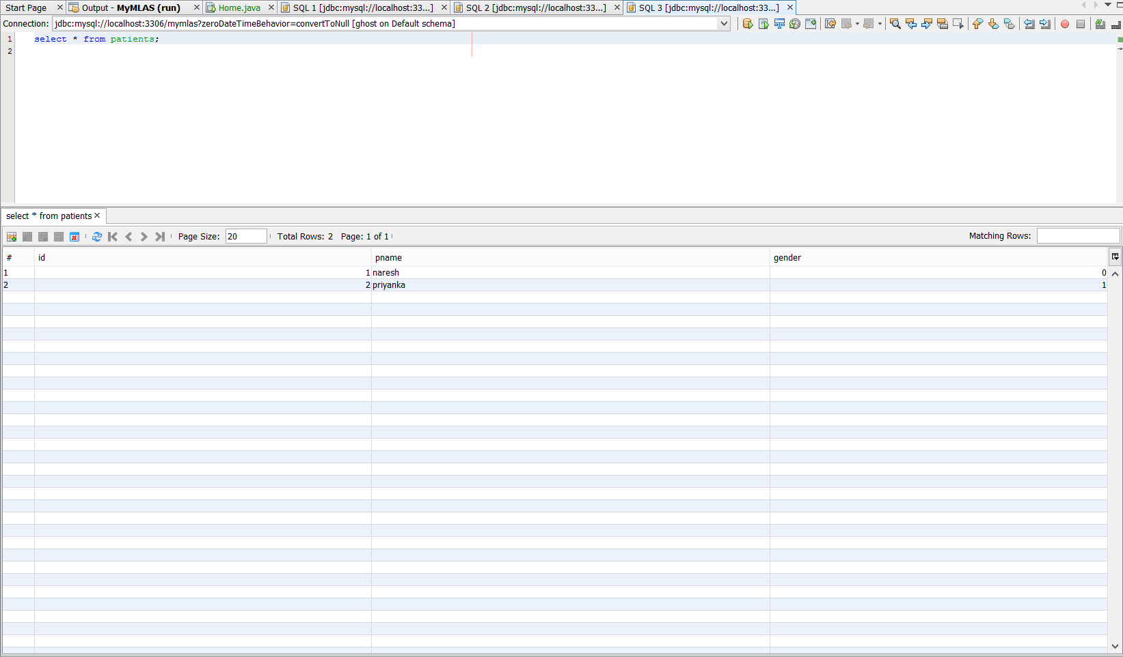

#### Add Patient (Success)

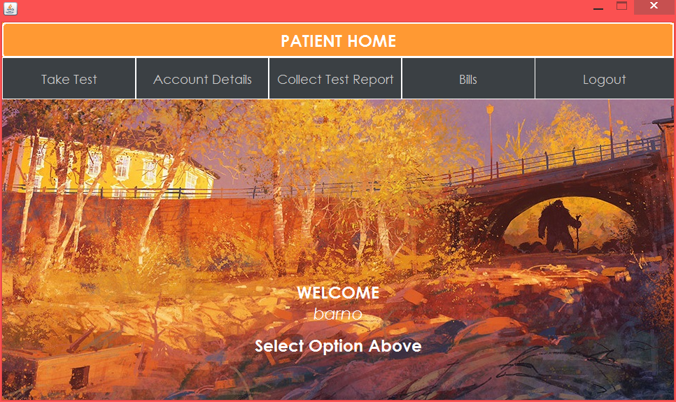

#### Database after addition of Patient

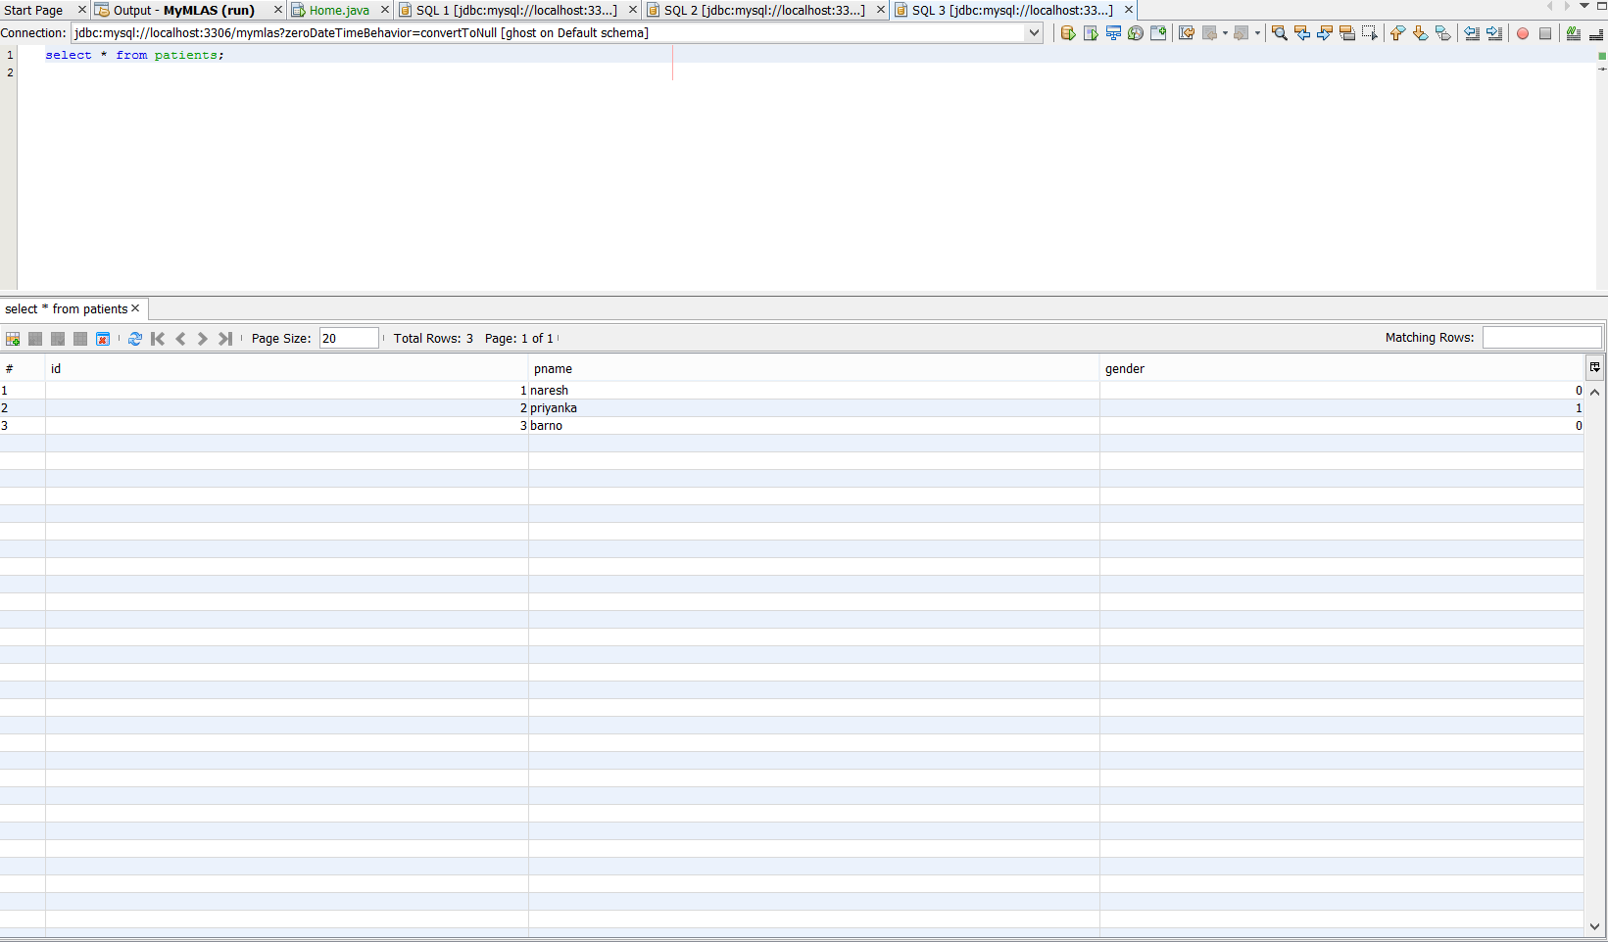

### Generation Of Bill

#### Notification for Generation of Bill

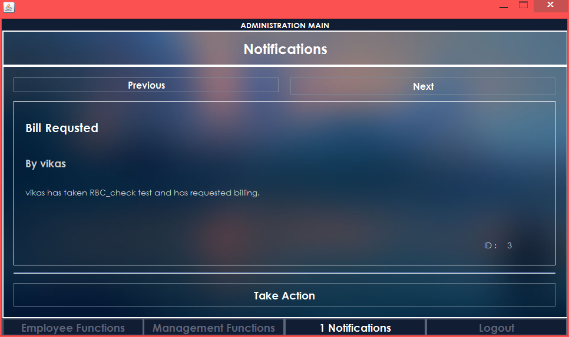

#### Database before Bill Generation

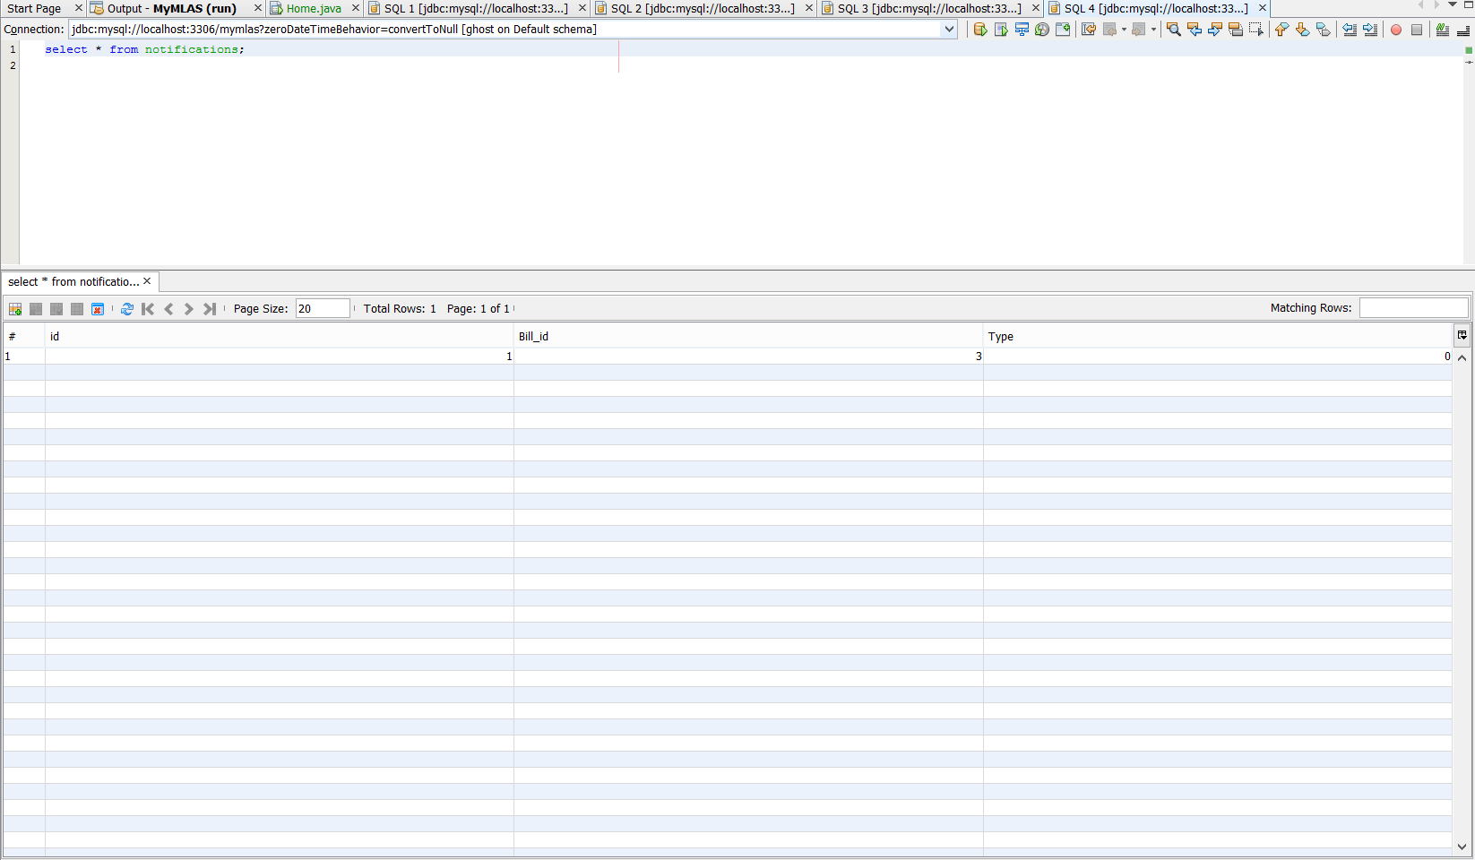

#### Generate Bill

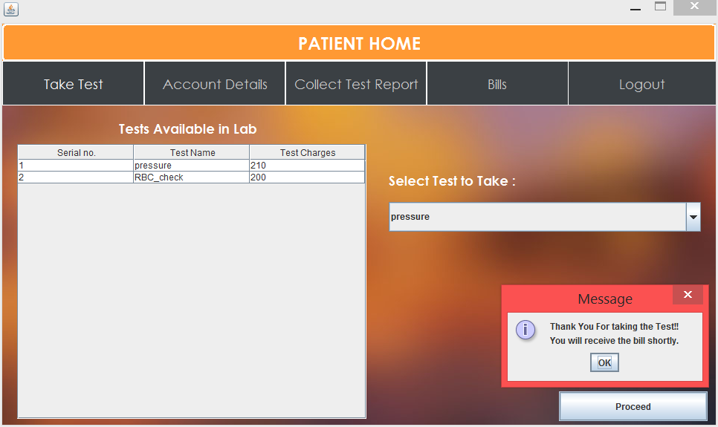

#### Bill Generation (Success)

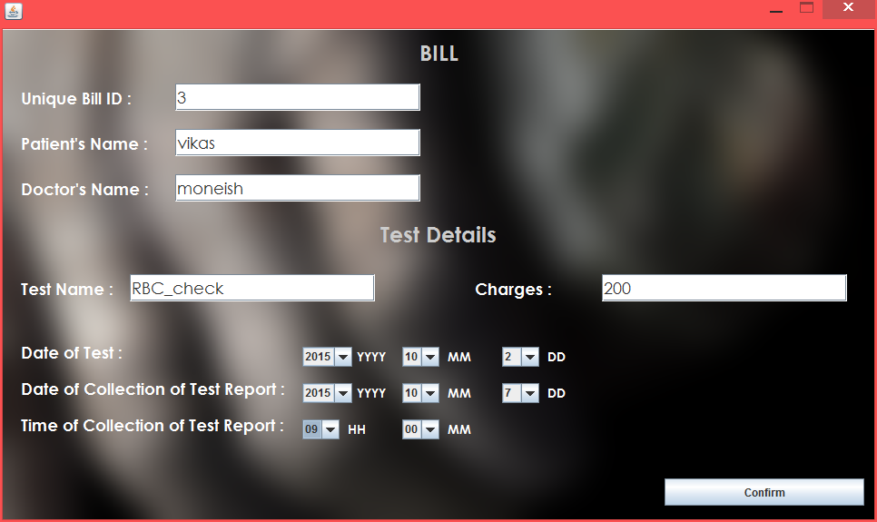

#### Database after Bill Generation

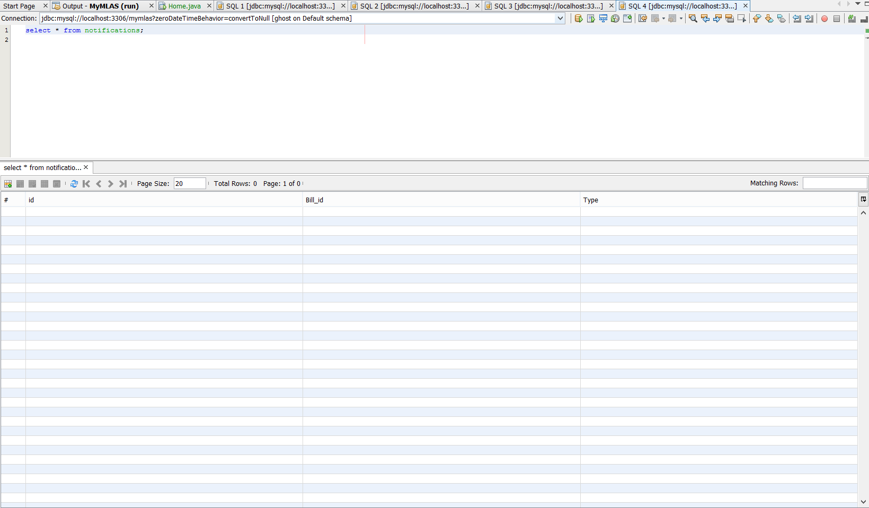

### Generate Test Report

#### Test Report notification

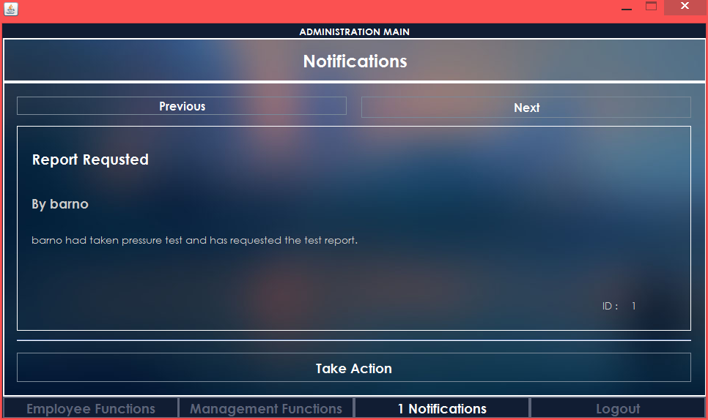

#### Database before Test Report Generation

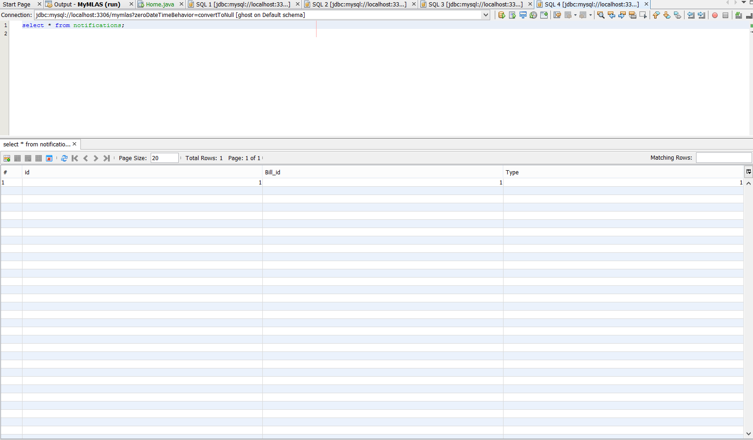

#### Generate Test Report

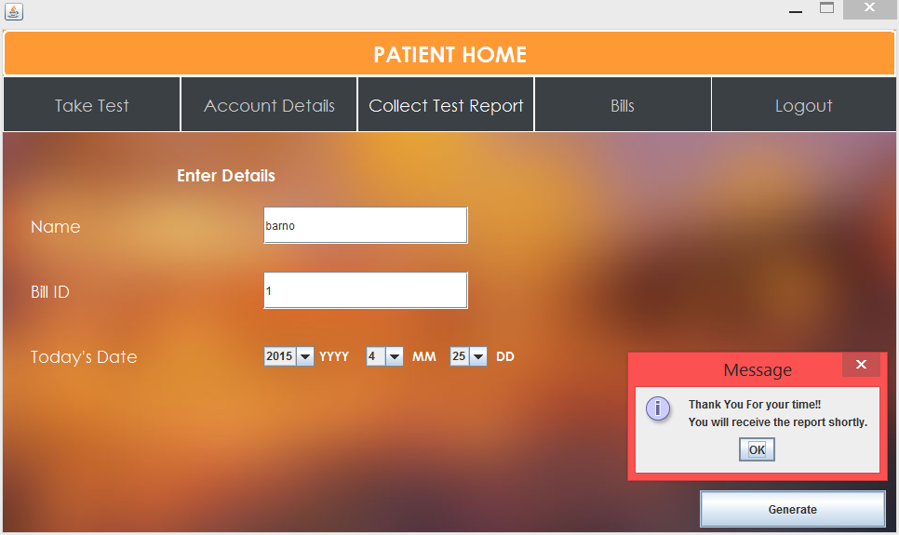

#### Test Report Generated (Success)

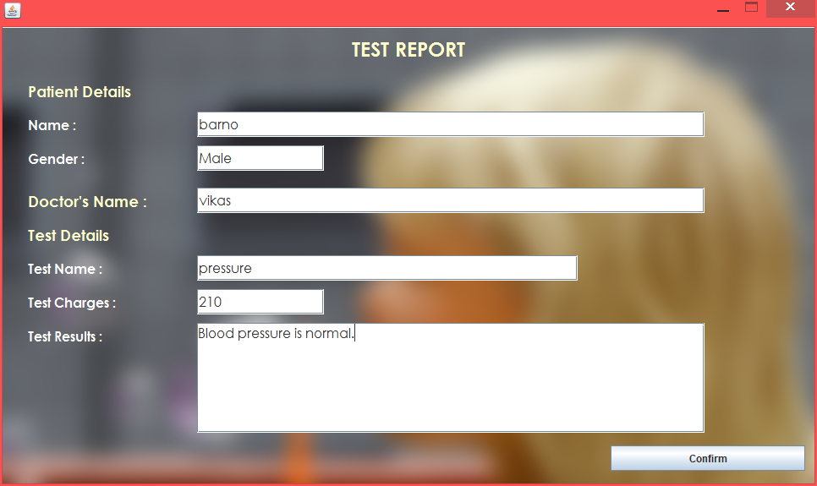

#### Database after Test Report Generation

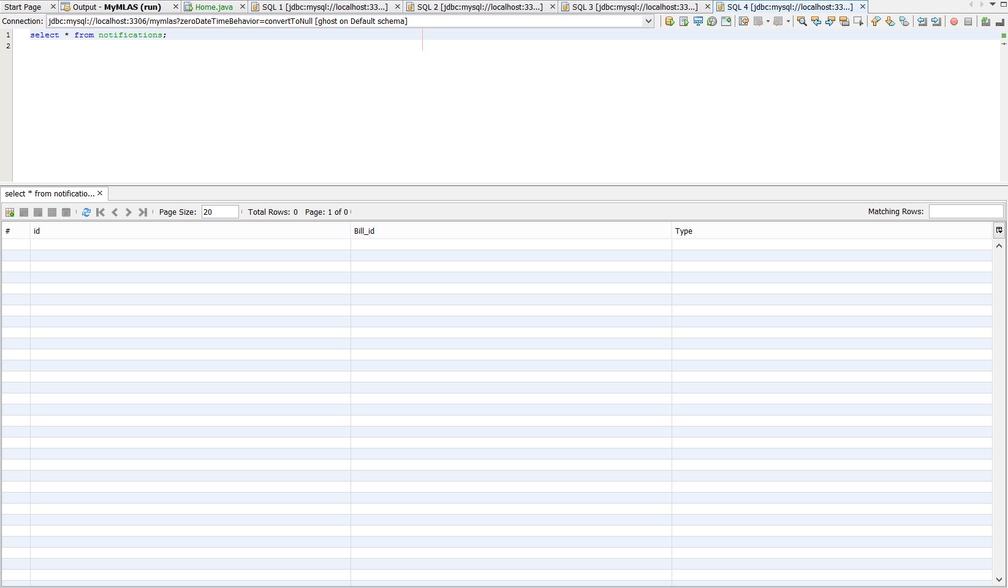

### Low Stock Notification

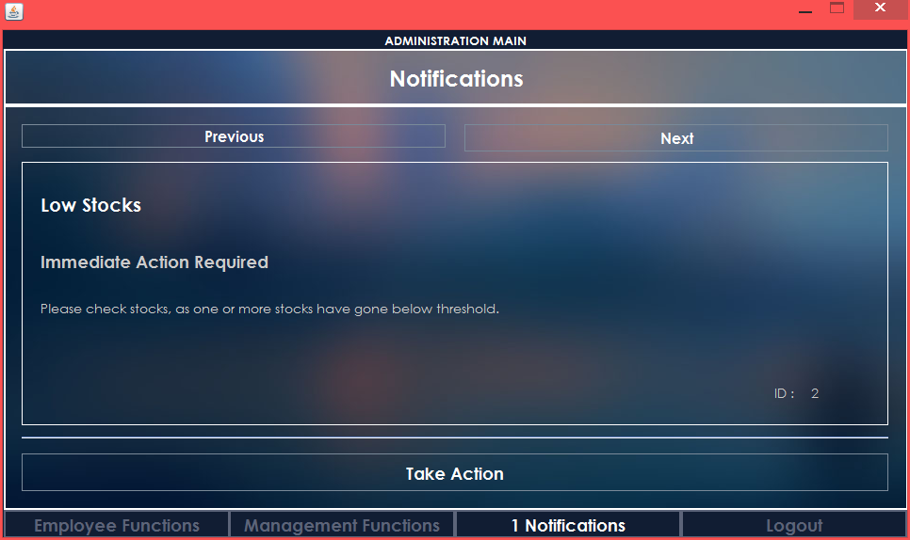

## Patient Page

### Take Test

#### Database before Taking Test

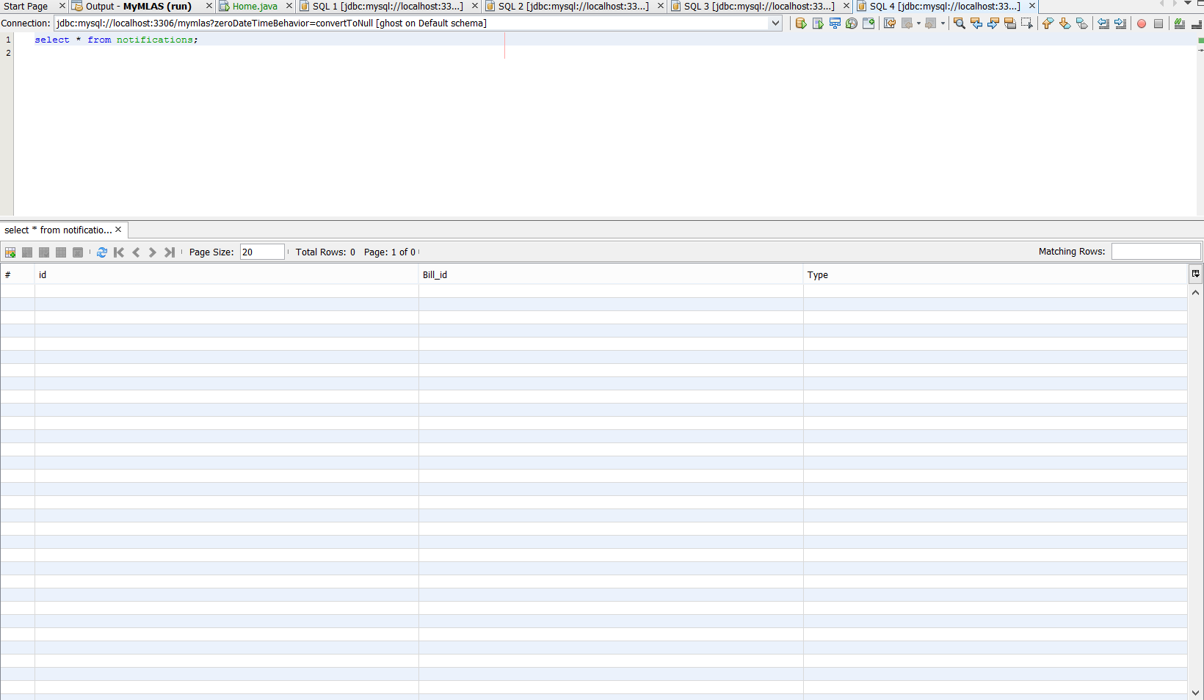

#### Take Test (Success)



#### Database after Taking Test

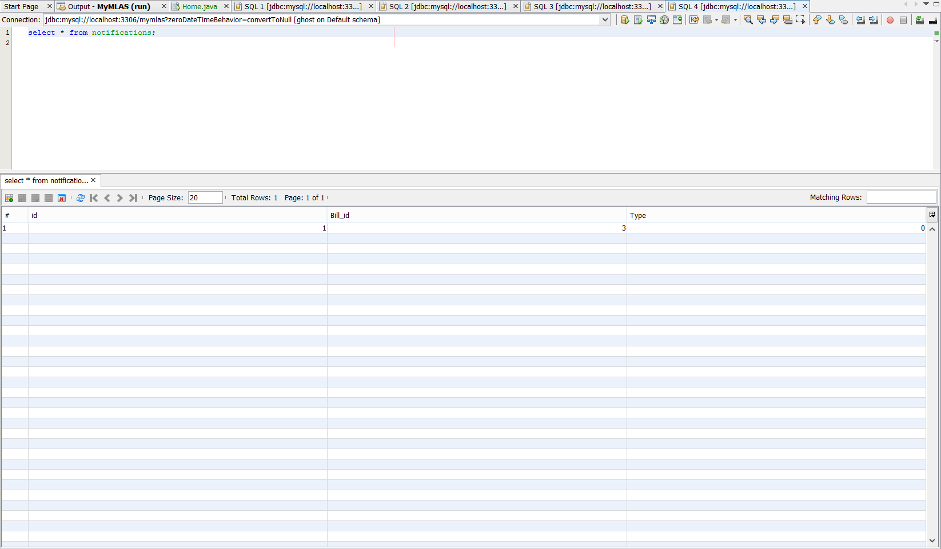

### Collect Bill

#### Collect Bill

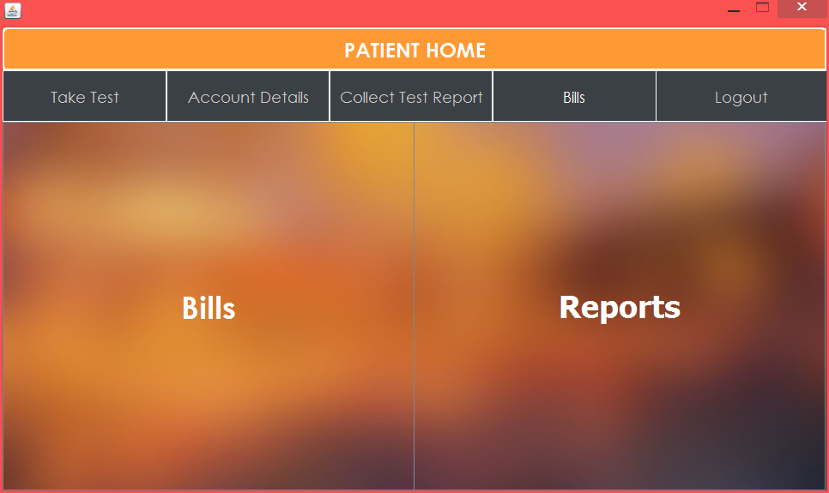

#### Bill Table

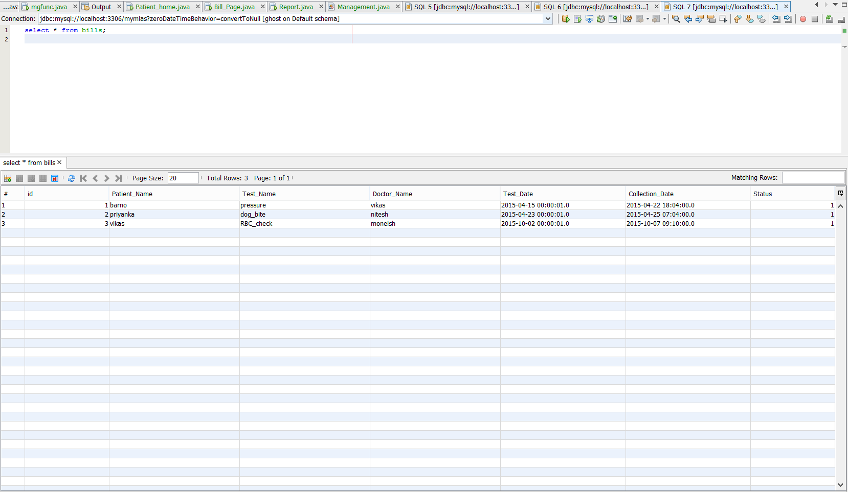

#### Bill Generated (Success)

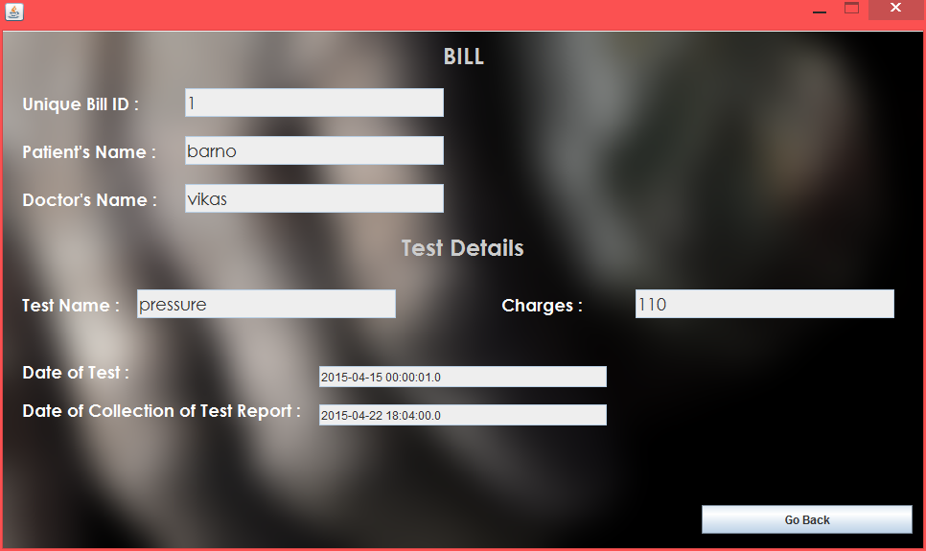

### Collect Test Report

#### Collect Test Report



#### Test Report Collected (Success)

